# Module 3: Trigonometric Identities, Inverse Functions, and Applications

### VI. Vectors

After completing this section, you should be able to:

* manipulate vectors graphically and algebraically
* find the angle between two vectors
* solve applied problems involving vectors

#### A. Vectors and Equivalence

A nonzero vector is a directed line segment. A nonzero vector has a **magnitude** and a **direction**.



A vector is denoted by (a letter with an arrow) or **v** (a boldface letter).

**v** is read as "vector v." The magnitude of **v** is denoted .

Vectors are often used in applications involving displacement, velocity, or force. For example, if you are walking west at 5 miles per hour, your velocity can be represented by a vector **v** of magnitude 5, pointed west.



This vector is in the direction of 180 or π (measured from the positive x-axis). Its magnitude is = 5 mph.

The **zero vector**, denoted **0**, is a special vector with magnitude  = 0, and having no defined direction.

For example, if you are standing still, your velocity can be represented by the vector.

|  |  |
| --- | --- |
| Suppose a vector **v** extends from point A to point B. The point A is the **initial point** of the vector and the point B is the **terminal point** of the vector. The magnitude of the vector is the distance between points A and B. The vector **v** may be denoted .  In the case of the zero vector , the initial point A and the terminal point B are the same. |  |

Two vectors are **equivalent** if they have the same magnitude and the same direction.

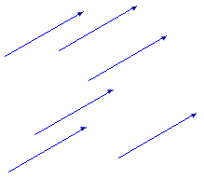

equivalent vectors

#### B. Scalar Multiplication, Addition and Subtraction of Vectors

##### **Scalar Multiplication**

A vector can be "scaled" by multiplying it by a real number, called a **scalar**.

Given a vector **v**, the scalar multiple 2**v** is the vector that has the same direction as **v** and is twice as long. The scalar multiple ½**v** is the vector that has the same direction as **v** and is half as long. The scalar multiple –**v** is the vector whose direction is opposite that of **v**.

|  |  |  |  |
| --- | --- | --- | --- |
|  |  |  |  |
| **v** | 2**v** | ½ **v** | –**v** |

In general, given a scalar k and a vector **v**, the vector k**v** is called a **scalar multiple** of **v**.

If |k| > 1, k**v** is a stretching of the vector **v** by a factor of |k|.  
If |k| < 1, k**v** is a shrinking of the vector **v** by a factor of |k|.  
If k > 0, then the direction of the vector k**v** is the same as the direction of **v**.  
If k < 0, then the vectors **v** and k**v** have opposite directions.

##### **Addition**

|  |  |
| --- | --- |
| Suppose you start at a street corner A and walk 4 blocks north to point B. This action can be represented by a displacement vector , which has a magnitude of 4 and direction of north.  Then walk 3 blocks east to point C. This action can be represented by a vector  of magnitude 3 and direction of east.  You started at point A and finished at point C. Your overall displacement is represented by the vector . In your walk you have added the vectors  and  to get . |  |
| In general, to add two vectors **u** and **v** graphically, position the initial point of **v** at the terminal point of **u**.  The **sum** **u** + **v**, called the **resultant**, is the vector that extends from the initial point of **u** to the terminal point of **v**. |  |
| Reversing the roles of **u** and **v**, to find the sum **v** + **u**, position the initial point of **u** at the terminal point of **v**.  **v** + **u** is the vector which extends from the initial point of **v** to the terminal point of **u**.  The sum **v** + **u** has the same magnitude and direction as **u** + **v**, so **v** + **u** and **u** + **v** are equivalent: **u** + **v** = **v** + **u**. |  |
| The sum **u** + **v** is the diagonal of a parallelogram whose sides are determined by the vectors **u** and **v**.  In the diagram, vectors **u**, **v**, and **u** + **v** are depicted with the same initial point. |  |
| The diagonal **u** + **v** splits the parallelogram into two congruent triangles ABC and CDA whose sides have lengths , , and . The angles at A, B, and C in triangle ABC have the same measures as the corresponding angles at C,D, and A in triangle CDA. |  |

##### **Subtraction**

|  |  |
| --- | --- |
| To find the **difference** of two vectors, **u** – **v**, reverse the direction of **v** and add it to **u**.  That is, **u** – **v** = **u** + (–**v**).  Position the initial point of –**v** at the terminal point of **u**. The vector **u** – **v** extends from the initial point of **u** to the terminal point of –**v**. |  |

To subtract a vector **u** from itself, find **u** – **u** = **u** + (–**u**). The resultant vector extends from the initial point of **u** to the terminal point of –**u**. Since the initial point of **u** is the same as the terminal point of –**u**, the resultant vector **u** + (–**u**) must be **0**. That is, **u** + (–**u**) = **0**. The difference between a vector and itself is the zero vector, **0.**

Now consider how vectors are used in applications.

For applications involving navigation, a direction is often specified by a **heading**. A heading refers to an angle measured clockwise from the north.

For example, a heading of 60° indicates a northeasterly direction. A heading of 105° indicates a southeasterly direction.

|  |  |
| --- | --- |
|  |  |

**Example VI.B.1:** An airplane travels at an airspeed of 350 miles per hour and a heading of 60°. A wind of 52 miles per hour is blowing at a heading of 105°. Find the ground speed of the airplane and the direction of the airplane's course over the ground.

Solution:

Let **v** be the vector representing the plane's airspeed and heading. **v** has a magnitude of 350 mph and a heading of 60°.

Let **w** be the wind velocity vector. **w** has a magnitude of 52 mph and a heading of 105°.

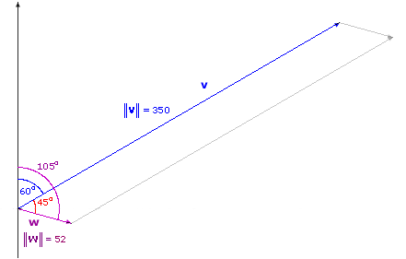

The angle between **v** and **w** has measure 105° – 60° = 45°.

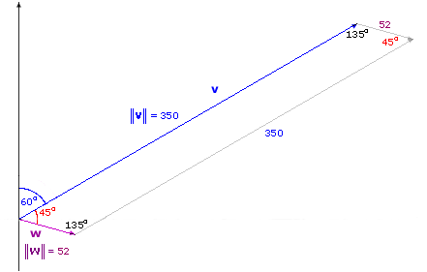

The vectors **v** and **w** determine a parallelogram. Since the parallelogram is symmetric, the opposite angles are equivalent, meaning the angle opposite the 45° angle will also be 45°. The sum of the measures of the angles of a parallelogram is 360°, so each of the two remaining angles must have measure ½[360° – (45° + 45°)] = ½(270°) = 135°.

The resultant vector **p** = **v** + **w** is the vector representing the plane's ground speed and course direction.

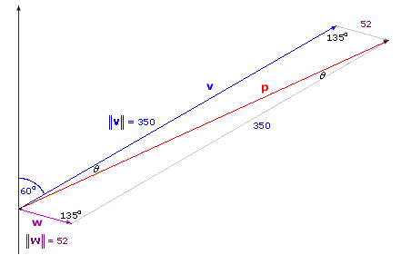

The ground speed is , the magnitude of **p**.

The angle between **v** and **p** is the drift angle θ. The heading corresponding to **p** is 60° + θ.

The goal is to find  and θ.

The parallelogram determined by vectors **v** and **w** has diagonal **p**. The diagonal **p** splits the parallelogram into two congruent triangles whose sides have lengths , , and . You already know that  = 350 and  = 52.

135° is the measure of the angle in each triangle formed by the sides of length 350 and 52. Since the lengths of two sides and the included angle are known, each triangle exhibits the SAS case. To find , use the law of cosines:

|  |  |
| --- | --- |
|  | = cos 135 ° |
|  | = 3502 + 522 – 2(350)(52)(–square root of 2/2) |
|  | ≈ 122,500 + 2,704 + 25,739 |
|  | ≈ 150,943 |

Then take the square root of both sides to get  ≈ 389 mph.

In order to determine the heading of **p**, first find θ. The law of cosines or the law of sines can be used.

If the law of sines is used:

|  |  |  |
| --- | --- | --- |
|  | = |  |
|  | = | Substitute. |
|  | = | Take reciprocals. |
| sin θ | = | Solve for sin θ. |
| sin θ | ≈0.0945 | Calculate. |
| θ | ≈ 5° | Find the angle whose sine is 0.0945. |

The course heading is 60° + θ ≈ 60° + 5° ≈ 65°. The ground speed of the airplane is approximately 389 miles per hour, and the heading is approximately 65°.

In example VI.B.1, you were given information about two vectors and then you determined the magnitude and direction of their sum. In the following example, you will be given information about a vector and you will find two vectors whose sum is the given vector.

**Example VI.B.2:** A 245-pound spherical lead ball is placed on a ramp having an incline of 22° with the horizontal.

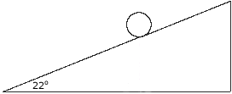

How much force is applied parallel to the ramp and how much force is applied perpendicular to the ramp?

Solution:

Let **w** be the vector representing the force of gravity on the ball. **w** has a magnitude  of 245 pounds and its direction is downward. For convenience, sketch the vector **w** so that its initial point is located on the ramp, below the ball.

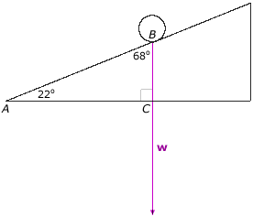

The vector **w** is perpendicular to the base of the ramp. A right triangle is determined by the ramp and the vector **w**, with acute angles of 22° and 90° – 22° = 68°. For convenience, label the right triangle ABC, with A corresponding to 22°, B corresponding to 68°, and C corresponding to the right angle.

Next, the idea is to write the vector **w** as a sum of two force vectors, with one of the two vectors parallel to the ramp, and the other vector perpendicular to the ramp.

Let **u** be the vector representing the force parallel to the ramp. One goal is to find , the magnitude of the force parallel to the ramp.

Let **v** be the vector representing the force perpendicular to the ramp. The second goal is to find , the magnitude of the force perpendicular to the ramp.

Roughly sketch the vectors **u** (parallel to the ramp) and **v**(perpendicular to the ramp), so that **w** = **u** + **v**. (By convention, vectors **u** and **v** and their sum **w** are shown below with the same initial point, B.)

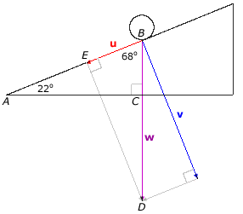

The object is to find  and , the magnitudes of **u** and **v**.

Vectors **u** and **v** determine a parallelogram having diagonal **w** and sides of length  and . Since **u** is parallel to the ramp and **v** is perpendicular to the ramp, **u** and **v** are perpendicular to each other. Therefore, the angles in the parallelogram are right angles, and the parallelogram is actually a rectangle.

The diagonal **w** splits the rectangle into two congruent right triangles. Each right triangle has legs of lengths  and , and hypotenuse of length  = 245. One of the right triangles is labeled BDE, where B is the initial point of vectors **u**, **v**, and **w**; D is the terminal point of the vector **w**; and E is the terminal point of vector **u**. The angle at B is the angle between the sides formed by **u** and **w**. It coincides with the angle at B in triangle ABC, so its measure is 68°.

Referring to the right triangle BDE, the angle of 68° is adjacent to the side of length , and opposite the side of length . Now apply trigonometry to find  and .

cos 68° = / = /245, so  = 245 cos 68° ≈ 91.8 pounds

sin 68° =/ = /245, so  = 245 sin 68° ≈ 227.2 pounds

Therefore, there is a force of approximately 91.8 pounds acting parallel to the ramp and a force of 227.2 pounds acting perpendicular to the ramp.

#### C. Component Form and Operations on Vectors

Upon introducing a coordinate system, a vector may be described analytically using notation called **component form**.

|  |  |
| --- | --- |
| A vector is in **standard position** if its initial point is the origin.  A vector in standard position in the xy-plane is determined by its terminal point (a, b).  The component form of a vector**v** in standard position with terminal point (a, b) is denoted ‹a, b›. The real numbers a and b are called the components of **v**.  More generally, given a vector **v** having initial point (x1, y1) and terminal point (x2, y2), the component form of **v** is ‹x2 – x1, y2 – y1›. |  |

Two vectors are equivalent if and only if their corresponding components are equal.

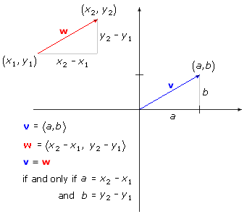

**Example VI.C.1:** Suppose points A, B, C, D, and E have coordinates as follows:

A (–3, 1), B (1, 4), C (4, 5), D (0, 2), and E (9, 10).

a. Determine the component form of the vectors , , , and .

b. Determine which of the vectors , , , and  are equivalent.

Solution:

a. Determine the component forms:

 = ‹1 – (–3), 4 – 1› = ‹4, 3›

 = ‹0 – 4, 2 – 5› = ‹–4, –3›

 = ‹4 – 0, 5 – 2› = ‹4, 3›

 = ‹9 – 1, 10 – 4› = ‹8, 6›

|  |  |
| --- | --- |
| b. Compare the component forms:   and  equivalent because their component forms are both ‹4, 3›.   has the same magnitude as  and  but has the opposite direction.   has the same direction as  and  but is twice as long.   and  are the only equivalent vectors of the group. |  |

Given the component form of a vector, it is easy to determine the magnitude.

# Magnitude (Length) of a Vector

The **magnitude** (or **length**) of a vector **v** = ‹v1, v2› is given by .

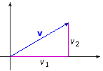

The illustration depicts a vector **v** placed in standard position, with components v1 and v2.

**Example VI.C.2:** Determine the length of the vector **w** = ‹4, –1›.

Solution:

The length of the vector **w** is .

A vector of length 1 is called a **unit vector**.

|  |  |
| --- | --- |
| There are certain special vectors with special designations:  The unit vector ‹1, 0› parallel to the x-axis is denoted **i**.  The unit vector ‹0, 1› parallel to the y-axis is denoted **j**.  The zero vector **0**has component form ‹0, 0›. |  |

The vector operations of scalar multiplication, addition, and subtraction can be performed using component form.

# Scalar Multiplication

Given a real number k and a vector **v** = ‹v1, v2›, the **scalar product** of k and **v** is the vector k**v**, given by

k**v** = k ‹v1, v2› = ‹kv1, kv2›

k**v** is called a scalar multiple of **v**.

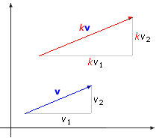

The illustration depicts two vectors in the xy-plane. It shows a vector **v** having components v1 and v2 and a scalar multiple k**v** for which k is larger than 1.

**Example VI.C.3**: If **v** = ‹1, –2›, find 3**v** and –2**v**.

Solution:

3**v** = 3‹1, –2› = ‹3, –6›

–2**v** = –2‹1, –2› = ‹–2, 4›

**Example VI.C.4:** Find a unit vector having the same direction as **v** = ‹3, 4›.

Solution:

The length of **v** is .

**v** is 5 times as long as a unit vector.

If **u** = 1/5 **v**, then **u** still has the same direction as **v**, but the length of **u** is 1/5 the length of **v**, so  = 1/5  = (1/5)(5) = 1.

Let **u** = 1/5 **v** = 1/5 ‹3, 4› = ‹3/5, 4/5›.

The vector ‹3/5, 4/5› is a unit vector having the same direction as **v**.

The work shown in the example can be generalized.

If **v** is a nonzero vector, then  is a unit vector in the same direction as **v**.

Vectors can be added by summing corresponding components.

|  |  |
| --- | --- |
|  | Let **w**be the sum of vectors **u** and **v**, with component form ‹w1, w2›.  The diagram illustrates that w2, the second component of **w**, is the sum of u2 and v2, the second components of **u** and **v**.  Similarly, it can be shown that w1, the first component of **w**, is the sum of u1 and v1, the first components of **u** and **v**. |

# Vector Addition and Subtraction

If **u** = ‹u1, u2› and **v** = ‹v1, v2›,  
then **u** + **v** = ‹u1+v1, u2 + v2› and **u** – **v** = ‹u1– v1, u2 – v2›.

**Example VI.C.5:** Let **u** = ‹3, –1› and **v** = ‹–1, 4›. Find **u** + **v**, **u** – **v**, 4**u** + 5**v**, , and **u** – 6**i**.

Solution:

|  |  |  |
| --- | --- | --- |
| **u** + **v** | = ‹3, –1› + ‹–1, 4› | Substitute. |
|  | = ‹3 + (–1), –1 + 4› | Add corresponding components. |
|  | = ‹2, 3› | Simplify. |
|  |  |  |
| **u** – **v** | = ‹3, –1› – ‹–1, 4› | Substitute. |
|  | = ‹3 – (–1), –1 – 4› | Subtract corresponding components. |
|  | = ‹4, –5› | Simplify. |
|  |  |  |
| 4**u** + 5**v** | = 4‹3, –1› + 5‹–1, 4› | Substitute. |
|  | = ‹12, –4› + ‹–5, 20› | Multiply by the scalars. |
|  | = ‹12 + (–5), –4 + 20› | Add corresponding components. |
|  | = ‹7, 16› | Simplify. |
|  |  |  |
|  | = | Substitute. |
|  | = | Compute the magnitude. |
|  | = | Simplify. |
|  |  |  |
| **u** – 6**i** | = ‹3, –1› – 6‹1, 0› | Substitute. |
|  | = ‹3, –1› – ‹6, 0› | Multiply by the scalar. |
|  | = ‹–3, –1› | Simplify. |

**Example VI.C.6:** Find the component form of 2**i** + 8**j**.

Solution:

|  |  |  |
| --- | --- | --- |
| 2**i** + 8**j** | = 2‹1, 0› + 8‹0, 1› | Substitute. |
|  | = ‹2, 0› + ‹0, 8› | Multiply by the scalars. |
|  | = ‹2, 8› | Add corresponding components. |

Example VI.C.6 showed how to write a combination of vectors **i** and **j** in component form. It is possible to carry out the reverse process: writing the component form of a vector **v** as a combination of the vectors **i** and **j**.

Any vector **v** = ‹v1, v2› can be expressed in terms of unit vectors **i** and **j**, by writing **v** = v1‹1, 0› + v2‹0, 1›, = v1**i** + v2**j**.

|  |  |
| --- | --- |
|  |  |
| The vector **v** = ‹v1, v2› = v1**i** + v2**j**has **horizontal component** v1**i** and **vertical component** v2**j**. | Example: ‹3, –1› = 3**i** – **j**. The horizontal component is 3**i** and the vertical component is –**j**. |

The components of a nonzero vector **v** can also be expressed in terms of the magnitude and the direction of **v**.

|  |  |
| --- | --- |
|  | Place **v** = ‹v1, v2› in standard position, and let θ be the angle that **v** makes with the positive x-axis. θ is called the **direction angle**.  The vector, **v**, its horizontal component, v1**i**, and its vertical component, v2**j**, form the sides of the reference triangle. The length of the hypotenuse is the magnitude  of **v**.  Using the reference triangle, it can be determined that  , so v1 = cos θ; and  , so v2 = sin θ.  Then **v**= v1**i** + v2**j** = cos θ **i** + sin θ **j**. |

# Horizontal and Vertical Components of a Vector

If **v** = ‹v1, v2› is a nonzero vector, v1 = cos θ and v2 = sin θ, where θ is the angle that **v** makes with the positive x-axis.

**v**= v1**i** + v2**j** = cos θ **i** + sin θ**j**

**Example VI.C.7:** Write the vector **u** = ‹3, –1› in terms of its magnitude and direction.

**Solution:**

|  |  |  |
| --- | --- | --- |
|  | Calculate the magnitude. |  |
|  | Calculate the cosine. |
|  | Calculate the sine. |

**Determine the direction angle:**

Since cosine is positive in quadrants I and IV, the equation has two solutions:

θ ≈ 18.4° or θ ≈ 360° – 18.4° = 341.6°.

However, since the vector ‹3, –1› in standard position is in quadrant IV, the direction angle θis approximately 341.6°.

Now **u** can be written in terms of its magnitude and direction:

**u** = cos θ **i** +  sin θ **j**

   =

#### D. The Dot Product and the Angle Between Vectors

# Dot Product

The **dot product** of vectors **u** and **v** is the real number **u**·**v**= u1v1 + u2v2. The dot product of a vector **u** with itself is the square of its length:

**u**·**u** = u12 + u22 = 2

**Example VI.D.1:** Let **u** = ‹4, –3›, **v** = ‹6, 8› and **w** = ‹–5, 2›. Calculate the dot products **u**·**v**, **v**·**w**, and **u**·**u**.

Solution:

|  |  |  |
| --- | --- | --- |
| **u**·**v** | = ‹4, –3›·‹6, 8› = 4(6) + (–3)(8) = 24 – 24 = 0 |  |
| **v**·**w** | = ‹6, 8›·‹–5, 2› = 6(–5) + 8(2) = –30 + 16 = –14 |
| **u**·**u** | = ‹4, –3›·‹4, –3› = 4(4) + (–3)( –3) = 16 + 9 = 25 |

The previous example illustrates that the dot product may be positive, negative, or zero. By examining the graph of the vectors in the example, notice that vectors **u** and **v** are perpendicular. Also note that the dot product of **u** and **v** is 0. This is not merely a coincidence! It turns out that the dot product plays a role in determining the angle between two vectors.

|  |  |
| --- | --- |
| The **angle between two vectors** is the smallest positive angle θ formed by the vectors.  This angle must be between 0 and π. |  |

The angle can be found by using the relationship described below.

# Angle between Two Vectors

Given nonzero vectors **u** and **v** and the angle θ between the vectors, cos θ =.

If the dot product **u**·**v** is 0, then cos θ = 0 and so θ must be 90°. Conversely, if θ = 90°, then cos θ = 0, and the dot product **u**·**v** must be 0.

Two vectors are perpendicular if and only if their dot product is 0.

The formula for the angle between two vectors can be established using the law of cosines.

**Example VI.D.2:** Prove the formula cos θ =for the angle between two vectors.

**Proof:**

Let **u** = ‹u1, u2› and **v** = ‹v1, v2› Let θ be the angle between **u** and **v**. Place vectors **u** and **v** in standard position. Construct the vector **w** = **u** – **v** = ‹u1– v1, u2 – v2›.

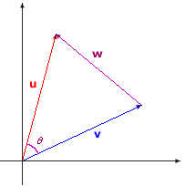

The square of the magnitude of **w** is .

The three vectors **u**, **v**, and **w** determine a triangle with sides of length , , and .

Apply the law of cosines: 2 = .

Substitute for 2 on the left side, and for 2 + 2 on the right side.

|  |  |
| --- | --- |
| (u1 – v1)2 + (u2 – v2)2 | = |

Multiply out the left side to get:

|  |  |  |
| --- | --- | --- |
|  | = | |
|  | = | Simplify. |
| u1v1 + u2v2 | = cos θ | Divide both sides by –2. |
| **u**·**v** | = cos θ | The left side is the dot product of **u** and **v**. |
|  | = cos θ | Solve for cos θ. |

**Example VI.D.3:** Find the angle between the vectors **u** = ‹2, –3› and **v** = ‹–1, 5›.

Solution:

|  |  |
| --- | --- |
| Calculate the dot product and the lengths of the vectors:  **u**·**v**   = 2(–1) + (–3)(5) = –2 – 15 = –17.      Apply the formula for the angle between two vectors:  cos θ  =   =   = |  |

Since the cosine is negative and the angle between vectors is less than 180° , θ is a quadrant II angle.

Solve the equation cos θ =  to get θ ≈ 158°. The angle between the vectors is approximately 158°.

[*Return to top of page*](https://umuc.equella.ecollege.com/file/51ed41e5-be80-4110-8171-a40ed58c98af/1/Vectors.html#pagetop)

[**Report broken links or any other problems on this page.**](http://help.umuc.edu/)  
  
[**Copyright © by University of Maryland University College.**](https://umuc.equella.ecollege.com/file/51ed41e5-be80-4110-8171-a40ed58c98af/1/MATH108-0609.zip/common/copyright.html)